Cloudera Certification Notes

# Hadoop

1. Distributed computing
   1. Motivation for distributed processing
      1. When handling extremely large files, not all the data will fit into memory
      2. Processing large amounts of data may take too long on a traditional system
      3. Handling huge amounts of data may not be cost effective
         1. Memory may not scale
         2. Disk storage systems may no longer be able to keep up at a reasonable cost
   2. Distributed systems
      1. Use multiple machines for single job
      2. Job is divided among the machines
      3. Job is moved to the data
      4. Pieces of the job are run in parallel
   3. Challenges
      1. Programming jobs can be complex
      2. Difficult to keep data and processes in synchronization
      3. Finite bandwidth sharing data and process info across nodes
      4. How does one deal with job failure or hardware failure?
2. The Hadoop framework solves the aforementioned challenges and hides the plumbing so that developers can focus on the analytics.
3. Radical new approach to distributed computing:
   1. Distribute data when the data is stored
   2. Run computation where the data is located
4. Originally based upon work done at Google
5. Open-source project overseen by Apache Software Foundation
6. Terminology
   1. Cluster - a group of computers working together
   2. Node – an individual computer in the cluster
      1. Master nodes control distribution of work and data to the slave nodes
      2. SR
   3. Daemon - a program running on a node
7. Core concepts
   1. Computation is based upon the Map-Reduce programming approach
   2. Nodes talk to each other as little as possible
   3. Data is distributed in advance when it is ingested
   4. Hadoop system scales to “Big Data” - Petabytes
   5. Hadoop system is fault-tolerant
      1. If job fails on one node, it is started again on another node
      2. One or more nodes fail → system not affected
8. Scalability
   1. Adding nodes adds capacity proportionally
   2. Increasing the load results in a graceful decline in performance, not failure of the entire system
9. Fault-tolerance
   1. What happens if a job on a node fails?
      1. The job manager assigns the job to run on a different node
      2. Original job is terminated
   2. What happens if one or more nodes fail due to a hardware/software problem?
      1. System continues to function
      2. Master re-assigns tasks to a different node
      3. Data replication ensures no loss of data
      4. Nodes which recover rejoin the cluster automatically
10. Use Cases
    1. Extremely large amounts of data
    2. Analysis or processing can be done in batch
    3. Analytic algorithm can be performed within the Map-Reduce framework
    4. All or most of the data must be scanned
    5. Data can be written one time and then read / analyzed multiple times
    6. Data typically unstructured - no set schema
11. Architecture of a Hadoop Cluster
    1. Hadoop Cluster: a group of machines working together to store and process data
    2. Two Master nodes
       1. NameNode
          1. Manages HDFS
          2. Knows where the data lives, on which node.
          3. The NameNode daemon has to be running for Hadoop to work.
             1. Must be running at all times.
             2. If the NameNode stops, then the cluster becomes inaccessible
          4. High Availability Mode
             1. Available in CDH4 and later
             2. Two NameNodes - one active and one on Standby
          5. Classic Mode
             1. One NameNode
             2. One “helper” node called the Secondary NameNode
       2. JobTracker
          1. Manages MapReduce
          2. Knows where the jobs are being run.
    3. Any number of Slave nodes
       1. Use HDFS to store data
       2. Run MapReduce jobs
12. HDFS Concepts
    1. HDFS is a filesystem written in Java
    2. Sits on top of native filesystem
    3. Provides redundant storage for massive amounts of data
    4. Files in HDFS are “write-once.” Files can be deleted but not updated.
    5. Ways to Access HDFS
       1. Shell: hadoop fs
       2. Java API
       3. EcoSystem Projects: Flume, Sqoop, Hue
    6. To work with data, you have to load it into HDFS.
       1. hadoop fs -put <source file> <destination file>
          1. This will copy the file to /user/<username>/<destination file>
          2. E.g., for the user pford, hadoop fs –put foo.txt foo-hdfs.txt copies foo.txt to /user/pford/foo-hdfs.txt
       2. SR
    7. More HDFS examples
       1. To get a directory listing of the user’s home directory in HDFS: hadoop fs –ls
       2. To get a directory listing of HDFS root: hadoop fs –ls /
       3. Display contents of HDFS file: hadoop fs -cat /user/username/bar.txt
       4. Copy a file to local disk from HDFS:  
          hadoop fs -get /user/<username>/<hdfs file> <local file>
       5. Create a directory called “input” in the user’s home directory:  
          hadoop fs -mkdir input
    8. HDFS performs best with a modest number of large files.
       1. Why? …. The NameNode stores file meta-data in memory.
       2. Thus, millions of files is better than billions.
       3. Files are typically 100MB or more in size.
    9. HDFS is optimized for large, streaming reads of files
    10. How HDFS stores files
        1. Data files are split into blocks and distributed at load time.
        2. Each block is replicated on multiple data nodes (default 3X).
        3. The NameNode stores metadata about the files in memory.  
           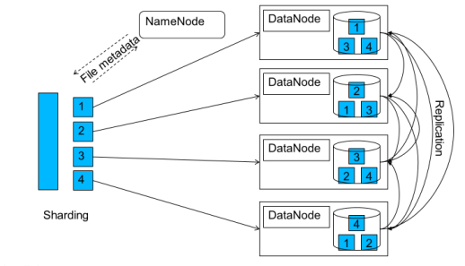
    11. SR

# MapReduce

1. The test is mostly about MapReduce.
2. MapReduce is a method for distributing a computational task across multiple nodes.
   1. MapReduce breaks complex tasks down into smaller elements which can run in parallel
   2. MapReduce programs can be written in Java, C++, Python, or Ruby.
   3. MapReduce programs are inherently parallel; thus they put large-scale data analysis in the hands of anyone with enough computers at his/her disposal.
3. Each node process the data stored on that node (when possible)
4. Consists of two major phases
   1. Phases
      1. The “map” - maps keys to values
      2. The “reduce” - reduces all values mapped to the same key
   2. Each phase has key/value pairs as input and output.
   3. The programmer writes a function for each phase: the **map** function and the **reduce** function.
      1. The input for the mapper function is the raw data.
      2. After the mapper completes, the MapReduce framework performs processing on the output (sorting and grouping the output by key) before passing it to the reducer.
      3. To write the map function, extend Hadoop’s Mapper class (an abstract class) and override the map method.
5. Features
   1. Automatic parallelization and distribution of jobs across the cluster
   2. Fault-tolerance
   3. A clean abstraction for programmers
      1. Jobs are usually written in Java
      2. Jobs can also be written in scripting languages using *Hadoop Streaming*
   4. MapReduce abstracts all of the housekeeping away from the developer
6. Terminology
   1. **Job** - a complete execution of Mappers and Reducers over a dataset
   2. **Task** - the execution of a single Mapper or Reducer over a slice of data
   3. **Speculative execution** - when Hadoop schedules another copy of a mapper task in order to speed up a slow running mapper.
   4. **Task Attempt** - particular instance of attempt to execute a task
      1. There will be at least as many task attempts as there are tasks
      2. When a task attempt fails, another is started either by the JobTracker (v1) or by the ApplicationMaster (v2)
      3. Speculative execution can result in more task attempts than completed tasks
7. Stages
   1. Mapper
      1. Mapper takes as input a key/value pair and will output a list of zero or more “intermediate” key/value pairs.
      2. Each map task (typically) operates on a single HDFS block
      3. Map tasks (usually) run on the node where the block is stored
      4. Mapper task intermediate data is stored on local disk, not HDFS.
   2. Shuffle and Sort  
      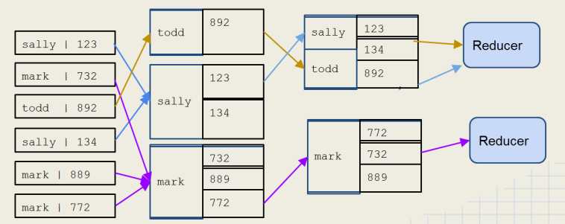
      1. Sorts and consolidates intermediate data from all the mappers
      2. Happens after all the map tasks are complete and before the Reduce starts
      3. Intermediate keys are grouped together
      4. Each key and value list is pulled by reducer from the intermediate data zone
         1. All values for intermediate key go to same reducer
         2. The intermediate keys/value lists are passed in sorted order
   3. Reducer
      1. Reducer outputs zero or more final key/value pairs for each input key - written to HDFS.
      2. Pulls shuffled/sorted intermediate data from Map tasks
      3. Operates on this data to reduce to one value per key.
      4. Produces final output, which it writes to HDFS.
      5. In the reduce phase, all items with the same key (from the various mappers) will be processed by the same reducer, guaranteed. Important to know for certain algorithms.
      6. Uses
         1. Summation
         2. Mat functions like max/min, avg.
         3. Collating
         4. Sorting
8. Mappers
   1. Mapper takes as input a key/value pair and will output a list of zero or more key value pairs.  
      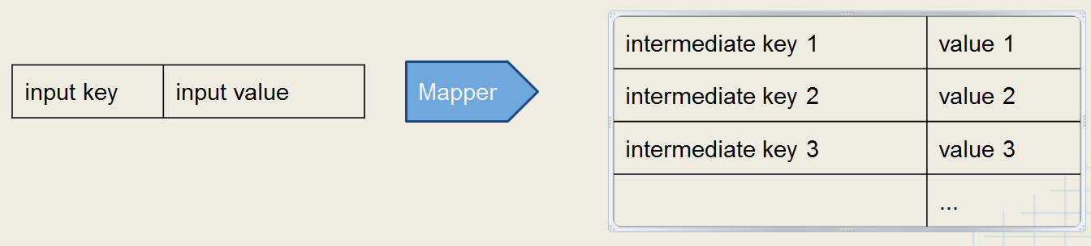
   2. The mapper does not have to use the input key.
      1. Use of the key is optional
      2. Often the mapper’s input key is irrelevant.
   3. If the mapper writes anything out, then the output must be in the form of key/value pairs
   4. Common Uses for Mappers
      1. Data Translation
         1. Convert input into upper case
         2. Convert text language
      2. Data “Explosion”
         1. Read in line of text but write out each instance of a word
         2. Useful in counting and sorting tasks
      3. Data Filtration
         1. Only output key/value pairs where some condition is true
         2. Useful for filtering type of data
         3. For example, getting temperature where it is greater than threshold.
      4. Changing Keyspaces - key mapped to lookup key
9. Reducers  
   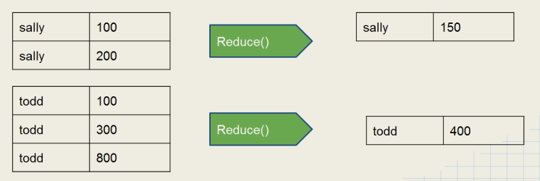
   1. Reducer outputs zero or more final key/value pairs for each intermediate input key - written to HDFS.
   2. Takes an intermediate key, with all of the intermediate values with that key, as input.
   3. Common uses for Reducers
      1. Summation
      2. Math functions: max/min, avg.
      3. Identity – dump out each value with the key
      4. Collating – group values by key
      5. Sorting
   4. How many reducers are needed?
      1. It is important to consider how many reducers should be specified when configuring the job.
      2. The default is a single reducer.
      3. With a single Reducer, one task receives all the keys in sorted order.
         1. This can be advantageous if the output must be in sorted order.
         2. However, this can cause performance issues if there is a large amount of intermediate data.
            1. In that case, the node running the reducer may not have sufficient disk space
            2. Thus, the job may take a long time to run.
      4. Some jobs may require a specific number of reducers, for example:
         1. Batching output by month [0..11] - specify 12 reducers.
         2. Batching output by day or week [0..6] - specify 7 reducers.
         3. Batching messages by hour of the day [0..23] - specify 24 reducers.
      5. Many jobs can be run with a variable number of reducers.
         1. Each reducer should get a reasonable amount of intermediate data, but not too much.
         2. The developer must decide how many to specify by:
            1. Testing the job first with a relatively small test data set,
            2. Then extrapolating to calculate the amount of intermediate data expected from the ‘real’ input data.
            3. Then using that result to calculate the number of reducers that should be specified.
      6. Note: you should take into account the number of Reducer slots likely to be available on the cluster.
         1. If your job requires one more Reduce slot than there are available, then a second wave of Reducers will have to run.
         2. In this way, while increasing the number of Reducers may cut down the time spent for each Reducer, the second wave may add more overall time to the job.
      7. SR
10. MapReduce 1.x vs. 2.x
    1. MapReduce V1
       1. Uses a JobTracker / TaskTracker architecture
       2. One JobTracker per cluster - limits cluster size to about 4000 nodes
       3. Slots on slave nodes designated for Map or Reduce tasks
    2. MapReduce V2
       1. Build on top of YARN
       2. Uses ResourceManager / NodeManager architecture - scalability
       3. Node resources can be used for any type of task
       4. Improves cluster utilization
       5. Support for non-MapReduce jobs
    3. MapReduce v1 Architecture  
       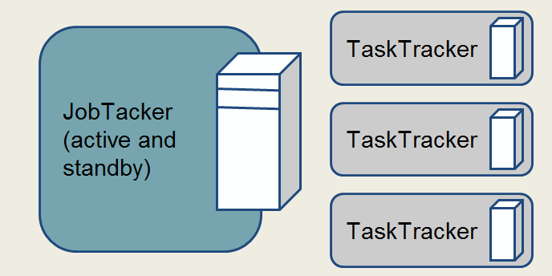
       1. One JobTacker per cluster that manages MR jobs and distributes tasks to TaskTrackers
       2. TaskTracker - one per slave node that starts and monitors Map or Reduce tasks
    4. Running a Job in a MapReduce v1 Cluster  
       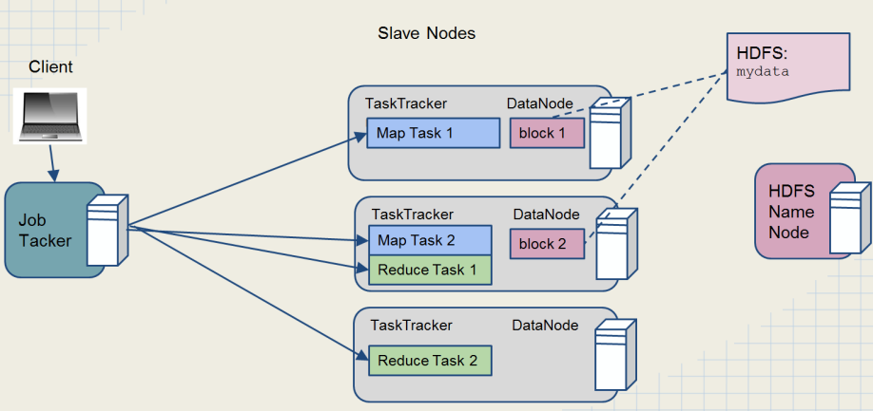
    5. MapReduce v2 architecture  
       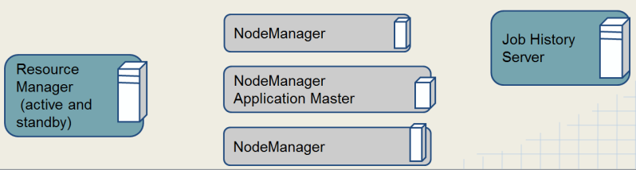
       1. **ResourceManager** - 1 per cluster, starts ApplicatonMasters and allocates resources on slave nodes
       2. **ApplicationMaster** - 1 per job, requests resources, manages MR tasks
       3. **NodeManager** - 1 per slave node, manages resources on slave
       4. **JobHistory** - 1 per cluster, archives jobs’ metrics and metadata
    6. Running a Job in a MapReduce v2 Cluster  
       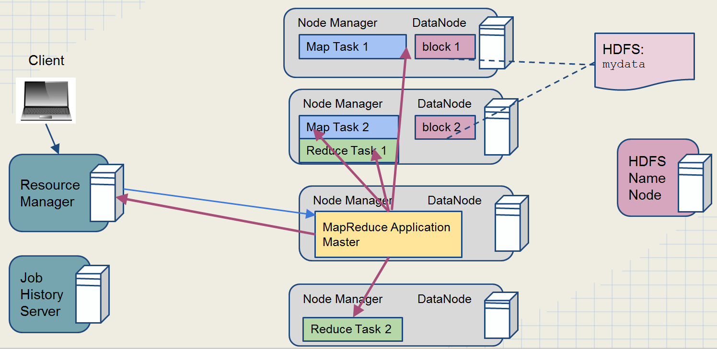
11. Job data
    1. Mapper Data Locality Preference
       1. When possible, Hadoop will attempt to run map tasks on the node where the block of data is stored locally.
       2. If this is not possible, the map task will transfer the data across the network as it processes that data.
    2. Where does the job data live?
       1. Mapper task intermediate data is stored on the local disk (not HDFS)
       2. What about reducers?
          1. There is no concept of data locality for reducers.
          2. Reducers pull the mapper intermediate data across the network.
          3. Reducers write their output to HDFS.
          4. The reduce method won’t start until all intermediate data has been transferred.
          5. However, Hadoop will start to allow reducers to pull intermediate data as soon as the mappers finish their work.
12. Speculative Execution
    1. It is possible for one map task to run more slowly than others:
       1. Faulty hardware
       2. Slow machine
    2. This would create a bottleneck since reduce method won’t start until all mappers have completed.
    3. Hadoop uses ***speculative execution*** to mitigate this condition.
       1. If a mapper appears to be running much more slowly than others, a new instance of the mapper will be started on another machine, operating on the same data (new task attempt for same task)
       2. The results of the first mapper to finish will be used.
       3. Hadoop will kill off the mapper that is still running.
13. Writing MapReduce jobs
    1. Components of a MapReduce job
       1. Write a **mapper**.
       2. Write a **reducer**.
       3. Write a **driver** program.
          1. Contains the main method which invokes the mapper(s) and reducer(s).
          2. Specifies job configuration and the type of components to use in the job.
       4. Other possible tasks to write[1]
          1. Combiner
          2. Partitioner
    2. The data passed to the mapper is specified by an ***InputFormat*** object.
       1. Specified in the driver code
       2. Defines the location of the input data - typically a file or a directory
       3. Determines how to split the input data into ***input splits***
          1. Each mapper deals with a single input split
          2. SR
       4. Creates a ***RecordReader*** object
          1. The RecordReader parses the input data into key/value pairs to pass to the mapper
          2. SR
       5. The default InputFormat is ***TextInputFormat***.  
          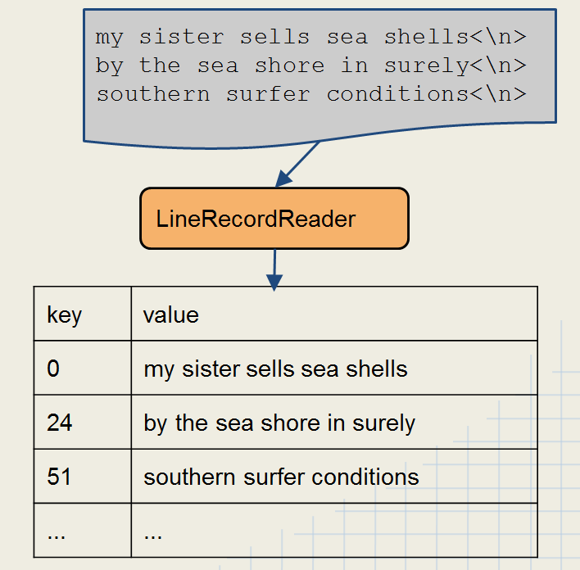
          1. Creates a group of ***LineRecordReader*** objects.
          2. Treats each \n-terminated line of a file as a value.
          3. The key is the byte offset of that line in the file.
       6. Other standard *InputFormat* classes
          1. ***FileInputFormat***: abstract base class used for all file-based InputFormats
          2. ***KeyValueTextInputFormat***: maps \n terminated lines as key[separator] value (tab is default)
          3. ***SequenceFileInputFormat***: binary file of (key,value) pairs plus meta-data
          4. ***SequenceFileAsTextInputFormat***: binary file of (key,value) but maps (key.toString(), value.toString())
14. Hadoop Wrapper Classes
    1. Keys and Values in Hadoop are wrappers objects around primitives
       1. Keys and Values are NOT primitives.
       2. This is done to support serialization for HDFS
       3. Examples:
          1. IntWritable -> int
          2. LongWritable -> long
          3. FloatWritable -> float
          4. DoubleWritable -> doubles
          5. Text -> String
    2. Values are objects which implement the ***Writable*** Interface.
    3. Keys are objects which implement ***WritableComparable*** Interface.
       1. A *WritableComparable* is a Writable which is also Comparable
       2. Two *WritableComparable* objects can be compared to determine their sort order.
       3. Keys must be *WritableComparable* so that they can be passed to the Reducer in sorted order.
       4. Hadoop box classes implement both *Writable* and *Comparable*.
          1. Ex: *IntWritable* is actually a *WritableComparable*.
          2. SR
15. ToolRunner
    1. The job configuration can be set in the job driver; however, doing so reduces portability.
    2. By implementing the Tool interface and extending the Configured class, we can leverage Hadoop’s *Configuration* object via the *GenericOptionsParser*.
       1. Hence, we can specify configuration at run-time via command line.
       2. hadoop jar uber.jar mypackage.MyDriver **-D mapred.reduce.tasks=1** input output
    3. How to use command-line parameters with the –D option[2]
       1. Extend Configured and implement Tool interface
       2. Anything specified in the option -D at command line becomes part of the Configuration:  
            
          hadoop jar myjob.jar package.MyDriver -D color=yellow inputDir outputDir
       3. Set the values onto the configuration object in main of the driver.

Configuration conf = new Configuration();  
conf.setInt(“favcolor”, “blue”); // blue is default color  
Job job = new Job(conf);

* + 1. Get the parameters within the mapper or the reducer.

Configuration conf = context.getConfiguration();

String myColor = conf.get(“favcolor”, “blue”);

* 1. ToolRunner command-line options[3]
     1. -D flag will override any default or site properties in the configuration but will not override those set in the driver code.
     2. -D options must appear before any additional program arguments:  
          
        hadoop jar myjob.jar MyDriver -D mapred.reduce.tasks=10 indir outdir

1. Mapper/Reducer initialization[4]
   1. If you want to perform some initialization prior to Map or Reduce, you can use the setup method.
   2. Some tasks that you may want to perform in setup:
      1. Initialize data structures
      2. Read from external file
      3. Grab parameters from the Configuration
   3. The setup method is run prior to the map or reduce method being called for the first time:  
      public void setup(Context context)
2. Mapper/Reducer teardown.
   1. Use the cleanup method to perform some action after all the records have been processed by your Mapper or Reducer.
   2. The cleanup method is called before the Mapper or Reducer terminates:
   3. Signature:  
      public void cleanup(Context context) throws IOException, InterruptedException
3. Side data distribution
   1. Often you will want to use some side data along with the processing going on in your Mapper or Reducer. For Instance:
      1. Lookup Tables
      2. Dictionaries
      3. Configuration values
   2. Options for accessing side data
      1. Use the Configuration
         1. In the setup method, use setter/getter methods on Configuration to access configuration properties.
         2. This works well for small amounts of data, but won’t scale because:
            1. Job configuration is read by JobTracker, TaskTracker, and child JVM.
            2. Every time configuration is read, all entries read into memory
      2. Use the Distributed Cache
         1. Distributed Cache
            1. A service for copying files and archives to task nodes.
            2. Files are copied in time for tasks to use them when they run.
            3. Files are normally copied to a node once per job.
            4. Files are automatically deleted from slave nodes when the job finishes.
         2. Files in Distributed Cache are read-only.
         3. Distributed Cache is the better method long-term. Very important.
         4. Distributed Cache is the only way to do a join between separate sets of data in Hadoop.
         5. Use ToolRunner to add files to Distributed Cache from command line.
            1. Don’t need to copy files to HDFS first.
            2. Use the -files option to add files:  
               hadoop jar myjob.jar MyDriver -files file1, file2, …, file_n
         6. The -archives flag adds archived files, and automatically unarchives them on the destination machines.
         7. The -libjars flag adds jar files to the classpath.
         8. Files added to the Distributed Cache are made available in your task’s local working directory.
            1. These files would be accessed from your mapper or reducer the same way that you would read any ordinary local file:  
               File f = new File(“file_loaded_into_cache”);[5]
            2. SR
4. Combiners
   1. Use them to help reduce large amounts of intermediate data.
   2. Mappers often produce large amounts of intermediate data.
      1. That data must be passed to the reducers.
      2. This can result in a lot of network traffic.
   3. One solution is to specify a Combiner
      1. This acts like a ‘mini-Reducer’
      2. The combiner runs locally on a single Mapper’s output.
      3. Output from the Combiner is sent to the reducers.
   4. Combiner and Reducer code are often identical.
      1. This is possible if the operation performed is commutative and associative.

Associative and Communicative operations

* **Associative** - order of operations doesn’t matter as long as sequence of operators is not changed.
  + addition and multiplication
  + min / max of a set
  + string concatenation
* **Commutative** - order of operands does not change the result
  + addition and multiplication
  + scalar multiplication of vectors
  + certain binary truth functions
  + intersection / union of sets
    1. Input and output data types for the Combiner/Reducer must be identical.
  1. The Combiner uses the same signature as the Reducer
     1. Input: key and a list of values
     2. Output: zero or more (key, value) pairs
     3. The actual method called is the reduce method in the class:  
        reduce(intermediate_key, [v1,v2, ...vn]) -> (result_key, result_value)
  2. Specify the Combiner class to be used in the Job’s Driver routine:

job.setMapperClass(WordMapper.class);  
job.setReducerClass(SumReducer.class);  
**job.setCombinerClass(SumReducer.class);**

* 1. Input and output data types for Combiner and Reducer must be identical
  2. The combiner may run once, or more than once on the output from any given Mapper.[6]

1. Partitioners
   1. The job of the partitioner is to determine to which reducer each intermediate key and its associated value will be sent.*  
      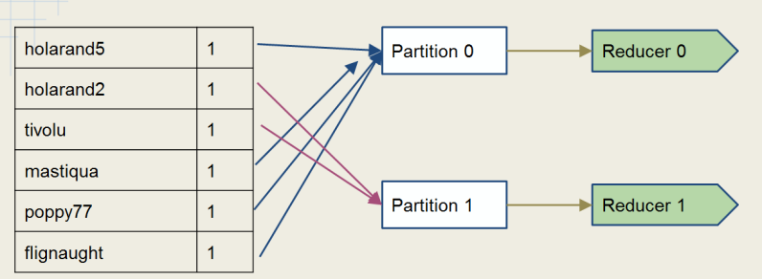
   2. Unless you specify a specific partitioner in the job configuration, then the default partitioner will be HashPartitioner.
      1. Guarantees that all pairs with the same key will go to the same Reducer
      2. Uses the hashcode() method of the key and modulo with the # partitions in order to determine which partition to send a the given (key,value) pair
      3. For most randomly-distributed data, this should result in all partitions being of roughly equal size.
   3. To specify a partitioner:  
      Job.setPartitionerClass(Class); // setPartitioner is a static method of *Job*.
   4. Relationship between partitioners and reducers
      1. The partitioners feed data into the shuffle and sort.
      2. The reducers pull data from the intermediate results from the partitioners.
      3. The type of partitioner and the configuration of the job determine how many reducers will be present in the job. [7]
      4. Again, the job of the partitioner is to determine to which reducer each intermediate key and its associated value will be sent.*
   5. How many reducers does one need?
      1. It is important to consider how many reducers should be specified when configuring the job.
      2. The default is a single reducer
      3. With a single Reducer, one task receives all the keys in sorted order
         1. This can be advantageous if the output must be in sorted order
         2. However, this can cause performance issues if there is a large amount of intermediate data.
            1. The node running the reducer may not have sufficient disk space.
            2. The job may take a long time to run.
   6. Getting sorted output
      1. If a job needs to output a file containing all the keys in sorted order, then a single reducer must be used.
      2. An alternative is to use the ***TotalOrderPartitioner***.
         1. This partitioner uses an externally generated file which contains information about intermediate key distribution.
         2. It partitions data such that all keys which go to the first reducer are smaller than any which go to the second, and so on…
         3. Therefore, the final output concatenated has the output files in a totally ordered list.
   7. Custom Partitioners
      1. To create your own partitioner custom class, implement the ***Partitioner*** interface

public interface Partitioner<K, V> extends JobConfigurable {  
 int getPartition(K key, V value, int numPartitions);  
}

* + - 1. You want a Partitioner which evenly distributes your map output.
      2. The getPartition method must return a number between 0 (inclusive) and the number of Reducers (exclusive).
         1. Make sure that the function you use to calculate the partition number does not return a negative number (wrap with Math.abs()).
         2. SR
    1. To use the customer Partitioner, configure your partitioner in the driver:  
         
       job.setPartitionerClass(MyCustomPartitioner.class);
    2. If you need to set up variables for use in the Partitioner, then implement ***Configurable***.[8]
       1. Any Hadoop object that implements *Configurable* allows its setConf() method to be called one time during instantiation.
       2. Thus you can set up variables in the setConf() method which your getPartition() method will then be able to access.
    3. Use cases
       1. The keys for your data are not evenly distributed but skewed in some way.
       2. You have a key that is a custom WritableCompable which contains a pair of values (A, B).
          1. You may need all keys with same value for A to go to same Reducer.
          2. Default partitioner won’t work in this case.
       3. You are performing a secondary sort.
    4. Native Hadoop Partitioners
       1. ***BinaryPartitioner***
          1. Used for when you have keys which are ***BinaryComparable***.
          2. The partition based upon the configurable part of the bytes array returned by BinaryComparable.getBytes().
       2. ***HashPartitioner***
          1. The default Partitioner that uses the key’s hashcode() method
          2. SR
       3. ***KeyFieldBasedPartitioner***
          1. Allows for using only parts of the key for comparison
          2. Programmer would configure the separator that separates the parts of the key.
       4. ***TotalOrderPartitioner***
          1. Used in conjunction with *InputSampler* or some other sampled index.
          2. *TotalOrderPartitioner* uses an external sample index to set the partition.

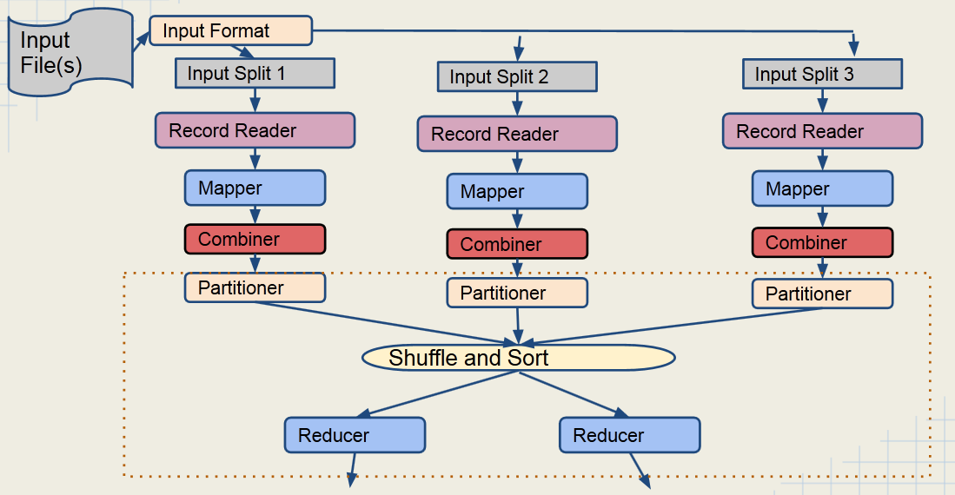

Figure : Partitioner Data Flow

1. Other important classes in the Hadoop API
   1. ***InverseMapper*** - swaps keys and values
   2. ***RegexMapper*** - extracts text based on a regular expression
   3. ***IntSumReducer*** - adds up all Integer values for a key
   4. ***LongSumReducer*** - adds up all Long values for a key
2. Old vs. New Java APIs
   1. The new API, sometimes referred to as “Context Objects,” was designed to make the API easier to evolve in the future.[9]
      1. It is type-incompatible with the old, however, so applications need to be rewritten to take advantage of it.
      2. SR
   2. Differences
      1. The new API favors abstract classes over interfaces, since these are easier to evolve.
         1. This means that you can add a method (with a default implementation) to an abstract class without breaking old implementations of the class.
         2. For example, the Mapper and Reducer interfaces in the old API are abstract classes in the new API.
      2. The new API is in the org.apache.hadoop.mapreduce package (and subpackages). The old API can still be found in org.apache.hadoop.mapred.
      3. The new API makes extensive use of context objects that allow the user code to communicate with the MapReduce system.
         1. The new Context, for example, essentially unifies the role of the JobConf, the OutputCollector, and the Reporter from the old API.
         2. SR
      4. In both APIs, key-value record pairs are pushed to the mapper and reducer, but in addition, the new API allows both mappers and reducers to control the execution flow by overriding the run() method.
         1. For example, records can be processed in batches, or the execution can be terminated before all the records have been processed.
         2. In the old API this is possible for mappers by writing a MapRunnable, but no equivalent exists for reducers.
      5. Job control is performed through the Job class in the new API, rather than the old JobClient, which no longer exists in the new API.
      6. Configuration has been unified.
         1. The old API has a special JobConf object for job configuration, which is an extension of Hadoop’s vanilla Configuration object (used for configuring daemons).
         2. In the new API, job configuration is done through a Configuration, possibly via some of the helper methods on Job.
      7. Output files are named slightly differently: in the old API both map and reduce outputs are named part-nnnnn, whereas in the new API map outputs are named part-m-nnnnn, and reduce outputs are named part-r-nnnnn (where nnnnn is an integer designating the part number, starting from zero).
      8. User-overridable methods in the new API are declared to throw java.lang.InterruptedException.
         1. This means that you can write your code to be responsive to interrupts so that the framework can gracefully cancel long-running operations if it needs to.
         2. SR
      9. In the new API, the reduce() method passes values as a java.lang.Iterable, rather than a java.lang.Iterator (as the old API does). This change makes it easier to iterate over the values using Java’s for-each loop construct:  
           
         for (VALUEIN value : values) { ... }

## Advanced Topics

1. Debugging MapReduce Jobs
   1. Challenges of debugging in a distributed environment
      1. Troubleshooting and Debugging Map Reduce Jobs is different from standard programs
      2. Due to the distributed nature of MapReduce tasks, every instance of a mapper runs as a separate task, often on a different machine
      3. In such a scenario, it is difficult to attach a debugger to the process
      4. Different nodes mean that log files for tasks are spread around the cluster
   2. Challenges of “Big Data”
      1. Large amounts of data make it difficult to catch edge cases
      2. Unexpected inputs are likely to appear throughout large amounts of unstructured data
   3. Approach to MapReduce Debugging
      1. Start small and build incrementally
      2. Ensure that input data is in the expected format
      3. Use Hadoop’s various run modes to scale your development
      4. Use MRUnit and JUnit unit test framework and write unit tests
      5. Expect problems and catch exceptions
         1. A thrown exception will cause a job to fail
         2. Catch exception and then use logging to send a message to the log file
   4. Debugging Tools
      1. Hadoop Run Modes
      2. Control of Logging
      3. Unit Testing Library
      4. Job Counters
   5. Hadoop Run Modes
      1. Standalone or Local Mode
         1. Commonly used for development. In this mode, everything runs in a single JVM.
         2. Since everything is in a self-contained JVM, then you can attach a debugger from your IDE.
         3. Hadoop can run MapReduce in a single, local process
            1. Does not require any Hadoop daemons to be running
            2. Uses the local file system instead of HDFS
            3. Is a very useful way of quickly testing changes in code
         4. Limitations
            1. Distributed Cache is not available in this mode
            2. Any job can only specify a single Reducer
            3. Certain mistakes may not be caught

For example, attempting to share data between Mappers will work because the code is running in a single JVM

* + - 1. How to run in Local Mode
         1. Option 1: add the following line to your driver code:

Configuration conf = new Configuration();

conf.set(“mapred.job.tracker”, “local”);

conf.set(“fs.default.name”, “file:///”);

* + - * 1. Option 2: set the fs and jt options on the command line if your driver uses ToolRunner:

fs is equivalent to -D fs.default.name

jt is equivalent to -D maprep.job.tracker

Example:  
$ hadoop jar myjar.jar MyDriver -fs=file:/// -jt=local indir outdir

* + 1. Pseudo Distributed Mode
       1. Useful for development and debugging, but simulates a real Hadoop cluster without some of the limitations of Standalone Mode.
       2. However, all of the Hadoop Daemons run on one node.
    2. Fully Distributed Load
       1. Used for production and large-scale testing of development.
       2. Uses a real cluster of machines with multiple nodes.

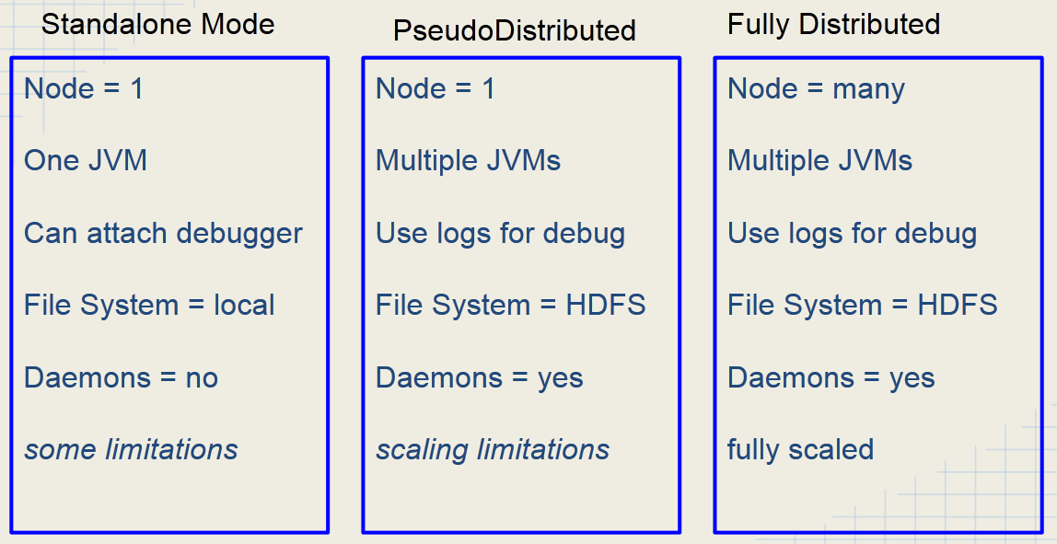

Figure : Differences between Hadoop Run Modes

* 1. Logging
     1. Writing to Standard Output or Standard Error
        1. Many Java programmers like to write debug messages to standard output[10]
        2. stdout and stderr will show results if running in LocalJobRunner Mode
        3. If running on a cluster, that output will not appear on your console
           1. However, stdout and stderr will be visible via Hadoop’s Web UI
           2. SR
     2. Using log4j
        1. Hadoop uses the log4j library to generate all of its log files
        2. Your Mappers and Reducers can also use log4j, initialized “automagically” by Hadoop
        3. Add log4j.jar-<version> file from the distribution or place the dependency in your Maven pom.xml file

import org.apache.log4j.Level;

import org.apache.log4j.Logger;

class GooMapper implements Mapper {

private static final Logger LOGGER = Logger.getLogger

(GooMapper.class.getName());

…

}

* + - 1. Simply send strings to loggers tagged with severity levels

LOGGER.trace(“debug message”);

LOGGER.debug(“debug message”);

LOGGER.info(“Smurf Hammer for the win”);

LOGGER.warn(“Invalid path for xyz”);

LOGGER.error(“Application has generated invalid value”);

* + - 1. Beware of expensive operations like string concatenation in log messages.
      2. Node-wide configuration for log4j is stored in /etc/hadoop/conf/log4j.properties
      3. You can override settings for your application either in your own log4j.properties or by setting the log level programmatically (e.g., LOGGER.setLevel(Level.WARN)).
      4. Setting the log levels for a job
         1. You can tell Hadoop to set logging levels for a job using configuration properties:

-mapred.map.child.log.level

-mapred.reduce.child.log.level

* + - * 1. Examples

To set the logging level to DEBUG for the Mapper:  
hadoop jar myjob.jar MyDriver -Dmapred.map.child.log.level=DEBUG

To set the logging level to WARN for the Reducer:  
hadoop jar myjob.jar MyDriver -Dmapred.reduce.child.log.level=WARN

* + 1. Where to find Hadoop log files
       1. Log files are stored on the machine where the task attempt ran.
       2. The location is configurable.
       3. Default location: /var/log/hadoop-0.20-mapreduce/userlogs/${task.id}/syslog
       4. You will often not have ssh access to a node to view its log files
          1. Much easier to use the JobTracker Web UI which can automatically retrieve and display the log files for you.
          2. SR

1. Unit testing
   1. MRUnit is Apache Hadoop’s testing framework. Built upon Junit and Mockito
      1. JUnit - provides familiar unit testing framework
      2. Mockito - used to mock up MapReduce framework

<dependency>

         <groupId>org.apache.mrunit</groupId>

         <artifactId>mrunit</artifactId>

         <version>0.9.0-incubating</version>

         <classifier>hadoop2</classifier>

 </dependency>

<dependency>

     <groupId>junit</groupId>

     <artifactId>junit</artifactId>

     <version>4.4</version>

     <scope>test</scope>

</dependency>

<dependency>

        <groupId>org.mockito</groupId>

        <artifactId>mockito-all</artifactId>

        <version>1.9.5</version>

        <scope>test</scope>

</dependency>

Figure : Maven Depndencies for MRUnit

* 1. MRUnit can be used to test the Mapper, the Reducer, or the full MapReduce Flow
     1. MR Unit builds on top of JUnit
     2. MRUnit provides a mock InputSplit and other classes
     3. @Begin
        1. Set up your MapDriver, ReduceDriver, or MapReduceDriver
        2. Set up your mapper and your reducer
     4. @Test
        1. Set up input expectations and output expectations
        2. Run your Mapper or Reducer or both
  2. MRUnit Approaches
     1. MRUnit supports two testing.
        1. Tell the framework both input and output values and let the framework do the assertions. (This is the simpler and easier approach)
        2. The more traditional approach where you do the assertion yourself.
     2. Running under your development environment
        1. Tests can run within your IDE (Eclipse, IntelliJ, Netbeans)
        2. Tests could run at the command line or batch (Hudson, CruiseControl)
        3. You do not need the Hadoop Install in order to use MRUnit
  3. Use a driver in order to run your tests
     1. MapDriver - for your mapper
     2. ReduceDriver - for your reducer
     3. MapReduceDriver - for your full MapReduce Flow
  4. Input and Output Methods
     1. withInput
        1. Specifies input to the Mapper/Reducer
        2. Has a builder method that can be chained
     2. withOutput
        1. Specifies expected output from the Mapper/Reducer
        2. Has a builder method that can be chained
     3. addOutput
        1. Similar to withOutput but returns void
        2. SR
  5. Methods to run tests
     1. runTest - runs the test and verifies the output
     2. run - runs test and returns result set, ignores prvious withOutput and addOutput calls
  6. Drivers take a single (key,value) pair as input
  7. Drivers take multiple (key,value) pairs as expected output
  8. If you are calling driver.runTest() or driver.run() multiple times, then call driver.resetOutput() between each call. Otherwise, MRUnit will fail.

1. Counters
   1. Counters allow Mappers or Reducers to pass aggregate values back to the job driver after the job has completed
      1. Their values are also visible from the JobTracker’s Web UI
      2. Values are also reported back on the console after a job completes
   2. Counters are very basic - just have a name and a value
   3. Counters are collected into Groups - within group, each counter has a name
   4. Example: a group of Counters called RecordType
      1. Names: TypeAlpha, TypeBeta, TypeKappa
      2. Appropriate counter can be incremented as each type of record is read in the mapper
   5. Counters can be set and incremented via the getCounter method:  
      context.getCounter(“RecordType”, “Alpha”).increment(1);
   6. To retrieve counters in the driver code, use code like this:

long typeAlphaRecs = job.getCounters().findCounter(“RecordType”, “Alpha”).getValue();  
long typeBetaRecs = job.getCounters() .findCounter(“RecordType”, “Beta”).getValue();

* 1. Do not rely on a counter’s value from the Web UI while a job is running
     1. Due to possible speculative execution, a counter’s value could appear larger than the final value
     2. Modifications to counters from subsequently killed/failed tasks will be removed from the final count.

1. IdentityReducer
   1. Doesn’t reduce, but you would use it to make sure that shuffle-and-sort still happens:
      1. Shuffle and sort doesn’t happen without a reducer.
      2. SR
   2. SR
2. Sequence files
   1. SequenceFiles are files containing binary-encoded key-value pairs
      1. Work naturally with Hadoop data types
      2. Include metadata which identifies the data types of the key/value
   2. Three file types in one
      1. Uncompressed
      2. Record-compressed
      3. Block-compressed
   3. Often used in MapReduce
      1. SequenceFileInputFormat
      2. SequenceFileOutputFormat
   4. How to access sequence files directly

Configuration config = new Configuration();

SequenceFile.Reader reader =

new SequenceFile.Reader(FileSystem.get(config), path, config);

Text key = (Text) reader.getKeyClass().newInstance();

IntWritable value = (IntWritable) reader.getValueClass().newInstance();

while (reader.next(key,value)) {

 // do something here

}

reader.close();

* 1. SequenceFiles are useful but have some potential problems
     1. They are only typically accessible via the Java API; however, some work has been done to allow access from other languages
     2. If the definition of the key or value object changes, then the file becomes unreadable
  2. Hadoop’s next generation of Sequence Files is Avro.
     1. Apache Avro is a serialzation format which is becoming a popular alternative to SequenceFiles
        1. Project was created by Doug Cutting, the creator of Hadoop
        2. SR
     2. Self-describing file format: schema for data included in the file itself
     3. Compact file format
     4. Portable across multiple languages: C, C++, Java, Python, and Ruby
     5. Compatible with Hadoop via the AvroMapper and AvroReducer classes

1. File Compression
   1. Important to know in Hadoop because Hadoop is distributed and compressed files cannot be split in all places, and not all compressed files are splittable.
   2. Hadoop works with a variety of file compression formats.
   3. If a compressed file is included as one of the input files, Hadoop will automatically decompress it and pass contents to the Mapper.
   4. Hadoop will support some common formats
      1. gzip
      2. bzip2
      3. LZO
      4. Snappy
   5. Considerations when using compression
      1. Compression within Mapper means less data being pulled across the network -> performance gains
      2. Compressing output will certainly lead to less disk space being consumed.
      3. Not every compression format is able to be split (eg. gzip)
         1. If file cannot be split, then everything in that file will be sent to a single mapper task.
         2. If input file size is sufficiently large, then using a non-splitable format may cause performance loss.
      4. Some compression algorithms take longer to compress/decompress and this may cause jobs to become CPU bound.
   6. Compression format characteristics

|  |  |  |  |
| --- | --- | --- | --- |
| **Format** | **Algorithm** | **Extension** | **Can Split?** |
| gzip | DEFLATE | .gz | NO |
| bzip2 | bzip2 | .bz2 | YES |
| LZO | LZO | .lzo | YES, if indexed |
| Snappy | Snappy | .snappy | NO |

* 1. LZO Compression
     1. LZO is capable of being divided into Hadoop splits
     2. Because of licensing restrictions, LZO cannot be shipped with Hadoop
        1. But… it is easy to add
        2. See https://github.com/cloudera/hadoop-lzo
     3. To make an LZO file splittable, you must first index the file
     4. The index file contains information about how to break the LZO file into splits that can then be decompressed
     5. Access the splittable LZO file as follows:
        1. Use LzoTextInputFormat class
        2. For streaming jobs, specify the input format on the command line property com.hadoop.mapred.DeprecatedLzoTextInputFormat
  2. The Snappy Codec
     1. Snappy is a relatively new and fast compression codec developed by Google.
     2. Snappy trades file compression size and compatibility of other formats for high speed. **Very Fast**.
     3. Snappy does not compress a SequenceFile and produce a file with a .snappy extension
        1. Instead, it is a codec that can be used to compress data within a file
        2. That data can be decompressed automatically by Hadoop or other programs at the time the file is read
        3. Snappy works well with SequenceFiles and Avro Files
     4. Snappy is now preferred over LZO
     5. Using Snappy compression
        1. Specify output compression in the Job object
        2. Specify either block or record compression (Block is recommended for Snappy)
        3. Set the compression codec to the Snappy codec in the Job object

import org.apache.hadoop.mapreduce.lib.output.SequenceFileOutputForma;

import org.apache.hadoop.io.SequenceFile.CompressionType;

import org.apache.hadoop.io.compress.SnappyCodec;

job.setOutputFormatClass(SequenceFileOutputFormat.class);

FileOutputFormat.setCompressOutput(job, true);

FileOutputFormat.setOutputCompressorClass(job, SnappyCodec.class);

SequenceFileOutputFormat.setOutputCompressionType(job, CompressionType, BLOCK);

Figure : Example of using Snappy compression

## Algorithms

1. Things to know
   1. You get a separate JVM for each mapper.
   2. SR
2. Sorting
   1. Using one reducer (easy)
      1. Remember that keys are passed to the Reducer from the Shuffle-Sort in sorted order.
      2. If we are only using one Reducer, then our output file will automatically be sorted.
      3. In such a case, the file to be sorted will have a mapper and reducer with identity functions
         1. Mapper - (k,v) -> (v, _)
         2. Reducer - (k, _) -> (k, ‘’)
   2. Using multiple reducers (much harder)
      1. Goal: Sort a large set of data by a sort key but do it in parallel with multiple reducers.
      2. This pattern produces a job composed of two major phases:
         1. Analyze Phase - sample data to build partition ranges for the data to build a set of partitions divided by the ranges of values that will build equal size subsets of data.
            1. The analyze phase is a random sampling of data and then the partition set is based upon that random sampling.
            2. Ahead of time, figure out how large of a sample you may need
            3. The mapper does simple random sampling outputting sort key as its output value - data will show up sorted at the reducer
            4. Only one reducer is used, and final output is totally sorted list
            5. The final list gets sliced into data range boundaries which will become partitions
         2. Sorting Phase - custom partitioner is used to partition data based upon the sort key
            1. Also called the Sorted List phase
            2. The order phase is a relatively straightforward application of MapReduce that uses a custom partitioner
            3. The mapper extracts the sort key but writes entire record as the value
            4. A custom partitioner (TotalOrderPartitioner) takes the data ranges from the partition file produced in the previous step and decides which reducer to send the data to.
            5. The reduce function simply takes the values that have come in and outputs them. (Remember, they are coming to each Reducer already sorted by the shuffle/sort.)
            6. The number of reducers needs to be equal to the number of partitions for the TotalOrderPartitioner to work properly.
   3. Secondary Sort
      1. Motivation: Sometimes, you want to sort by components of the key and the value of the record. For instance, you have a person’s last name as the key but you want to sort by Last Name, and then by First Name.  
         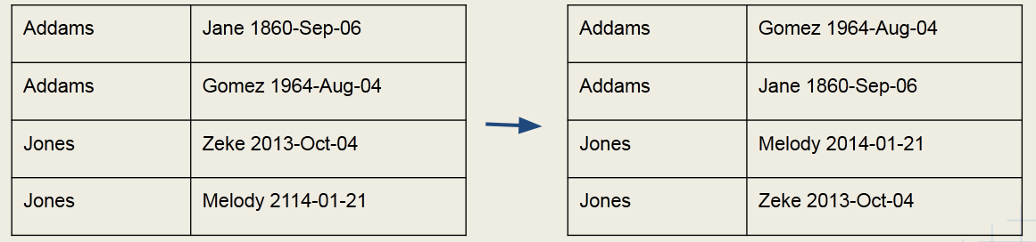
      2. “In reducer” versus “value to key”
         1. Hadoop automatically sorts data emitted by the mappers prior to sending this to the reducers - during shuffle-sort phase.
         2. We can take advantage of this sort phase for secondary sort.
         3. We have two options here:
            1. Have reducer buffer all values for given key and do “in-reducer” sort

might be the faster processing

but since reducer gets all values for given key, could run out of memory

* + - * 1. Create a composite key to natural key: “value to key” approach

offloads sorting to the MapReduce framework

Hadoop designed to do this

no risk of running out of memory

* + 1. Components of the Value to Key Secondary Sort
       1. Mapping Phase: Mapper is going to emit a composite key made up of the natural key, and part of the value
       2. Shuffle and Sort
          1. Custom partitioner is going to partition data by the natural key
          2. Sort Comparator is going to sort by the composite key
       3. Reduce: Grouping Comparator is going to group by the natural key for the reduce() calls
    2. Mapper - Creating the Composite Key
       1. The composite key will be necessary for the actual comparison for sorting. Intermediate key should be a composite of the natural key and something from the value.  
            
          let map(k,v) = emit( new Pair(v.getPrimaryKey(), v.getSecondaryKey() ), v)

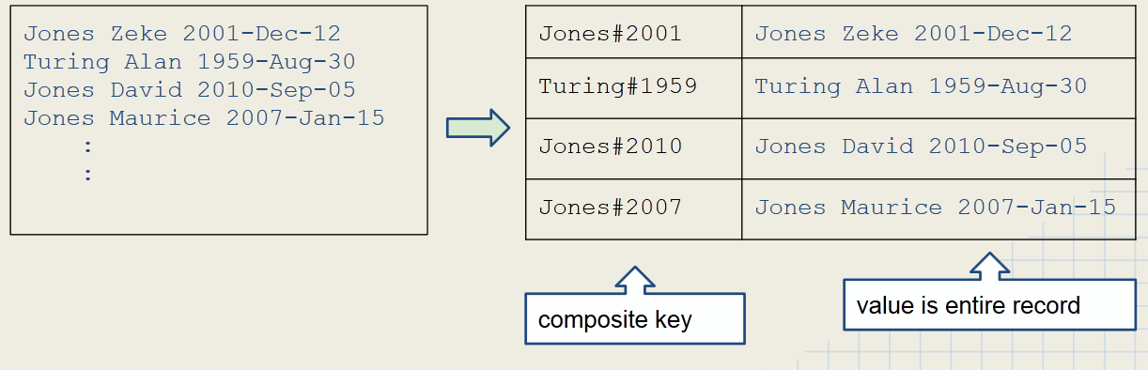

* + - 1. SR
    1. Partitioner - use natural key to determine which reducer  
         
       let getPartition(Pair k, Text v, int numReducers) = return(k.getPrimaryKey().hashCode % numReducers)  
         
       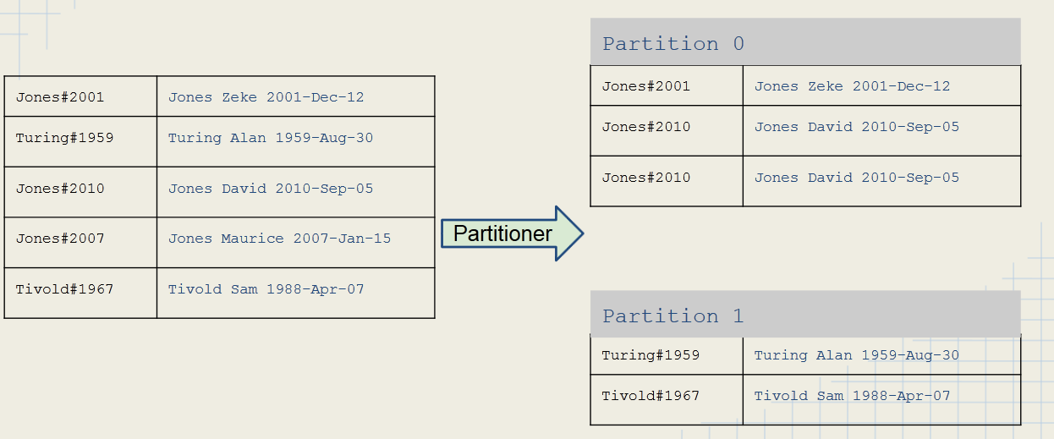
    2. Sorting Composite Keys
       1. Comparator classes are classes that compare objects
       2. compare(A,B) returns
          1. 1 if A > B
          2. 0 if A = B
          3. -1 if A < B
       3. Custom comparators can be used to sort composite keys
          1. extend WritableComparator
          2. Override int compare()
       4. Two comparators are required:
          1. Sort Comparator
          2. Group Comparator
    3. Sort Comparator
       1. The Sort Comparator will sort the input to the Reducer.
       2. It uses the full composite key, using first the natural key, and then the secondary key if natural keys are equal

let compare (Pair k1, Pair k2) = compare k1.getPrimaryKey(), k2.getPrimaryKey()

if equal then  
 compare k1.getSecondaryKey(), k2.getSecondaryKey()

Figure : Psuedocode

Johnson#8899 > Johnson#7231

Addams#4543 < Jones#3245

Pikachu#3422 < Pikachu#4399

Rarebit#1244 > Rarebit#007

Figure : Result of Sort Comparator sorting

* + 1. Grouping Comparator
       1. The Grouping Comparator uses only the natural key in order to determine which keys and values are passed in a single call to the Reducer
       2. let compare(Pair k1, Pair k2) = compare k1.getPrimaryKey(), k2.getPrimaryKey() results in:  
          Johnson#8899 = Johnson#7231  
          Addams#4569 < Jones#1972
    2. Setting Comparators in Secondary Sort Job Driver
       1. Set both a grouping comparator and sort comparator in your drive code
       2. Example:

public class MyDriver extends Configured implements Tool {

    public int run(String[] args) throws Exception {

        job.setSortComparatorClass(LastNameAndYearComparator.class);

        job.setGroupingComparatorClass(LastNameComparator.class);

    }

}

1. Searching
   1. Searching in Map-Reduce basically equates to a filter type operation
   2. Assumptions:
      1. The input is a set of files containing lines of text.
      2. The mapper has been passed a pattern to look for in the files.
   3. Algorithm
      1. Mapper compares the line against the pattern
      2. If the pattern matches, then the Mapper outputs something like:
         1. emit (line, _) OR
         2. emit (filename + line, _)
      3. Else emit nothing
   4. The reducer is simply the identity reducer that outputs each intermediate key
2. Indexing
   1. Inverted Index
      1. In computer science, an inverted index is an index data structure storing a mapping from content, such as words or numbers, to its locations in a database file, or in a document or a set of documents.
      2. The purpose of an inverted index is to allow fast full text searches, at a cost of increased processing when a document is added to the database.
      3. Common Uses
         1. Document retrieval systems
         2. Search Engines
         3. Bioinformatics - searching DNA fragments against reference DNA sequence
      4. Algorithm
         1. Mapper: For each word in the line, emit (word, filename)
         2. Reducer
            1. Identify function

Collect together all values for a given key (example: all filenames for a particular word)

Emit (word, filename_list)

* + - * 1. SR
    1. Inverted index data flow  
       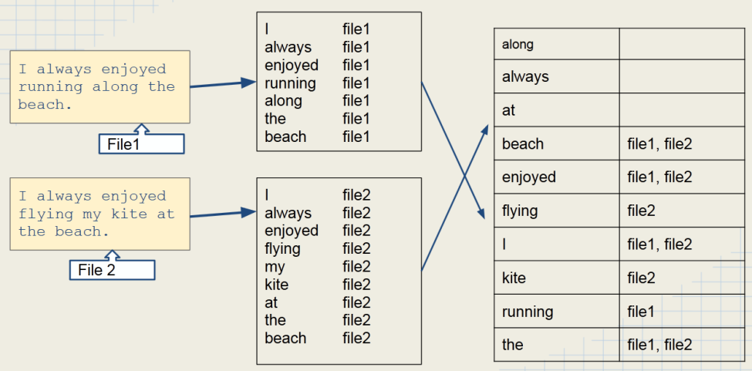
  1. SR

1. Joins
   1. In a relational database, joining sets of data together is useful and a common operation.
   2. In a relational database, joining sets of data together is easy.
   3. In Hadoop, joining sets of data together is a common operation as well.
   4. In Hadoop, programming a map-reduce job to perform a join is NOT easy
   5. Therefore:
      1. Avoid writing a map-reduce job to perform a join.
      2. Better to use Hive, Pig, or another tool to join data together.
   6. Map-side Join
      1. Algorithm
         1. Load the smaller set of data into memory - typically using a hash table.
         2. The key of the hash table is your join key.
         3. Map over the other set of data and perform a lookup on the hash table using the join key.
         4. If the join key is found, then join the record and emit the record.
      2. Map side joins have obvious scalability issues. Avoid this method unless you have a very small amount of the in-memory data set.
   7. Reducer-side Join
      1. This way is better than the Map-side join
      2. Algorithm
         1. Map over both sets of data.
         2. Emit a key/value pair for each record where key is the join key and value is the entire record.
         3. In the Reducer, perform the actual join.
      3. Note: Hadoop’s shuffle and sort will guarantee that values with the same key are brought together
   8. Key points
      1. Joins are usually best done using Impala, Hive, or Pig
      2. Map-side joins are simple, but they don’t scale well
      3. Use reduce-side joins when both datasets are large.
         1. Mapper
            1. Merges both data sets into a common record type
            2. Use a composite key (custom WritableComparable) with join on key/record type
         2. Shuffle and Sort
            1. Secondary sort so that ‘primary’ records are processed first
            2. Cusom Partitioner to ensure records sent to correct Reducer OR …
            3. Hack the hashCode of the composite key
         3. Reducer
            1. Group by join key (custom grouping comparator)
            2. Write out ‘secondary’ records joined with ‘primary’ record data

# Hadoop Ecosystem

## Sqoop

1. Covered heavily on the exam
2. Imports data from RDBMS to HDFS
   1. It can also export from HDFS to RDBMS
   2. Uses MapReduce to import the data.
      1. No reducer is used, however.
      2. Throttles the number of mappers to avoid overloading the cluster.
   3. Can import just one table, all tables in a database, or just part of a table (i.e., supports the WHERE clause).
   4. Can be used for incremental imports
      1. First import retrieves all rows in a table.
      2. Subsequent imports retrieve all rows created since the last import.
   5. Generates a class file which can encapsulate a row of the imported data
      1. Useful for serializing and de-serializing data in subsequent map-reduce jobs.
      2. SR
3. Basically a mapper job without a reducer.
4. By default, uses 4 mappers.
   1. This number is configurable, however.
   2. SR
5. Uses a JDBC interface
   1. Custom connectors exist for various RDBMSs.
      1. These use the RDBMS’s native protocols instead of JDBC.
      2. And that yields better performance.
   2. Custom connectors are not open source, but are free, and can be found at Cloudera’s site.
6. Syntax[11]
   1. Sqoop <tool-name> [tool-options]
   2. Tools include:
      1. import
      2. import-all-tables
      3. list-tables
      4. export
      5. create-hive-table
   3. Options include:
      1. --connect
      2. --username
      3. --password
   4. Examples
      1. Import a table called employees from a database called personnel in a MySQL RDBMS:

$ sqoop import --username gina --password muff3n! \

--connect jdbc:mysql://database.example.com/personnel \

--table employees

* + 1. Import MySQL DB table employees from DB personnel with ID > 1000:

$ sqoop import --username gina --password muff3n! \

-- connect jdbc:mysql://database.example.com/personnel \

--table employees --where “id > 1000”

* + 1. Export files from HDFS /user/gina/data using 5 mappers and inject their contents into the student1 table in the testDb database:[12]

$ sqoop export --connect jdbc:mysql://localhost/testDb \

--table student1 -m 5 --export-dir /uer/gina/data

## Pig

1. Apache Pig is a tool for data analysis and processing on Hadoop.
2. Pig offers an alternative to writing MapReduce code directly.
   1. You write in “Pig Latin Script”—a data flow language.
   2. Hadoop Pig converts the Pig Latin into one or more MapReduce jobs.
3. Pig has an interactive shell (called Grunt) where you can type statements.
   1. Pig interprets each Pig Latin statement as you type it.
   2. Execution is delayed until output is required.
   3. Useful for ad-hoc data inspection and debugging Pig Latin Scripts.
   4. To start Pig, type pig at the command line.
   5. Useful commands
      1. $ pig -help
      2. $ pig -version
      3. $ pig -execute
      4. $ pig *script.pig*
4. Pig supports many features which allow developers to perform data analysis without having to write Java Map Reduce code.
   1. Joining data sets
   2. Grouping data
   3. Loading non-delimited data
   4. Creation of user-defined functions one can write in Java.
5. Key Concepts
   1. In relational databases, we are used to dealing with relational data (rows, columns, fields).
   2. Pig uses similar concepts, but with different names:
      1. field - single element
      2. tuple
         1. Collection of values
         2. Analogous to a row in RDBMS
      3. bag
         1. Collection of tuples
         2. Analogous to a group of rows in RDBMS (though not analogous a table).  
            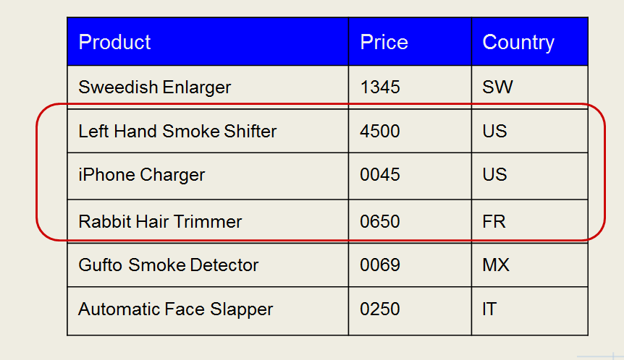

Figure 7: Example of a bag, multiple rows in a table.

1. Pig Latin Scripts
   1. Pig Latin is not like a traditional programming language
   2. Pig Latin is a data flow language - like a data workflow
      1. The flow of data is expressed as a sequence of statements.
      2. SR
   3. The typical Pig Latin script starts by loading one or more datasets into bags, and then creates new bags by modifying those it already has.

## Hive

1. Introduction
   1. Apache Hive is another tool to manipulate data
   2. Hive is a higher level of abstraction on top of map-reduce
   3. Hive uses an SQL-like language called HiveQL
   4. Hive Generates map-reduce jobs that run on the Hadoop cluster
   5. Hive was originally developed by Facebook but is now an Apache open-source project
2. Hive Components
   1. Hive runs on the client machine.
   2. Converts HiveQL queries into map-reduce jobs that run on the cluster.
3. Hive more DB like than Pig, which runs on files
   1. Hive queries operated on tables like a traditional RDBMS
      1. A table is an HDFS directory containing one or more files.
      2. Hive supports many formats for data storage and retrieval.
   2. The user must specify the structure and location of tables when the tables are created.
   3. Hive stores table information in its “metastore” which is contained in an RDBMS such as MySQL.
   4. When performing a query:
      1. Hive first consults the metastore to get table information.
      2. Hive then queries the tables.
4. Hive Data
   1. Hive data is stored in Hive’s warehouse directory in HDFS
      1. Default path: /user/hive/warehouse/<table_name>
      2. SR
   2. Tables represent subdirectories of the warehouse directory
   3. It is possible to create external tables if the data is already in HDFS and should not be moved from its current location
   4. Actual data is stored in flat files
      1. Control character-delimited text, or SequenceFiles
      2. Can be in arbitrary format with the use of a custom Serializer / Deserializer
      3. All data in a directory is considered to be part of the table data
5. Using the Hive shell
   1. While Pig is more batch oriented, Hive is meant to be interactive
   2. hive will get you into the shell, quit will get you out.
   3. Accessing Hive from the command line
      1. Can execute a file containing HiveQL code using -f option
      2. Can use HiveQL directly from the command line using the -e option
      3. Use the -S (silent) option to suppress informational messages.
         1. This can also be used with the -e or -f options
         2. SR
6. Loading Data Into Hive Tables
   1. Data is loaded into Hive with the LOAD DATA INPATH statement
      1. Assumes that the data is already in HDFS
      2. Example:   
         LOAD DATA INPATH “cust_data” INTO TABLE customers;
   2. If the data is on the local filesystem, use LOAD DATA LOCAL INPATH
      1. This automatically loads the data into HDFS in the correct directory
      2. SR
7. Loading data into Hive
   1. You can use the Sqoop --hive-import which will automatically create a Hive table from the imported data.
      1. Imports the data.
      2. Generates the Hive CREATE TABLE statement based on the table definition in the RDBMS.
      3. Runs the statement.
   2. SR
8. User-defined functions
   1. Hive supports manipulation of data via User-Defined Functions (UDFs) which are written in Java.
   2. Hive also supports user-created scripts written in any language via the TRANSFORM operator.
   3. Leverages Hadoop Streaming[13]
9. Limitations
   1. Hive is “SQL-Like,” so not all standard SQL is supported.
      1. Sub-queries are only supported in the FROM clause.
      2. No correlated sub-queries.
   2. No support for UPDATE.
   3. No support for DELETE.
   4. No support for INSERT on single rows.
   5. No transactions

## HBase

## ZooKeeper

## Hue

## Impala

1. Introduction
   1. Impala is a high performance SQL engine for ‘big data’
   2. Impala uses SQL
   3. Impala is 10 to 50 times faster than Hive, Pig, or MapReduce
   4. This means that Impala is feasible for interactive queries
   5. Achieves this speed by using a custom execution engine
   6. Does not have to translate query to Map-Reduce
   7. Impala was developed by Cloudera but is now 100% open source under Apache
2. Impala runs on Hadoop clusters  
   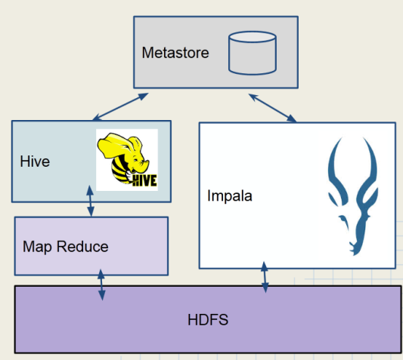

Figure : Impala vs. Hive Architecture

* 1. Data is stored in HDFS
  2. Does not use map-reduce
  3. Uses the same Metastore as Hive
  4. Impala uses a lot of cluster resources

1. Using the Impala shell
   1. Impala built for speedy interactive query
   2. impala-shell will get you into the shell, exit gets you out
   3. SR
2. Limitations[14]
   1. Impala does not currently support some features in Hive
   2. No complex data types (ARRAY, MAP, STRUCT)
   3. No support for a BINARY data type
   4. No custom file and row format (SerDes)
   5. There is no SQL-style authorization (privileges and roles)
3. Choosing between Impala, Hive, and Pig
   1. Use Impala when…
      1. You need near real-time responses to ad hoc queries.
      2. Or you have structured data with a defined schema.
   2. Use Hive or Pig when you need support for custom file types or complex data types
   3. Use Pig when…
      1. You have developers experienced with writing scripts.
      2. Your data is unstructured or semi-structured.
   4. Use Hive when you have very complex and long-running queries.
4. Pig, Hive, and Impala Comparison Chart

|  |  |  |  |
| --- | --- | --- | --- |
| **Features** | **Pig** | **Hive** | **Impala** |
| SQL-based query language | NO | YES | YES |
| Schema | Optional | Required | Required |
| Process data with external scripts | YES | YES | YES |
| Custom file format support | YES | YES | NO |
| Query Speed | Slow | Moderate | Fast |
| Accessible via ODBC/JDBC | NO | YES | YES |

1. Can Pig, Hive, and Impala now replace the traditional RDBMS?
   1. Relational databases are optimized for:
      1. Small amounts of data.
      2. Immediate results.
      3. In-place modification of data.
      4. Transactional support.
   2. Pig, Hive and Impala are optimized for:
      1. Large amounts of read-only data.
      2. Extensive scalability at low cost.
   3. Pig and Hive are better suited for batch processing.
   4. Impala and an RDBMS are better for interactive use.

## Oozie

1. Defines workflows

# Yarn

1. Combiners and partitioners would be used after the mappers and before the shuffle-and-sort stage in the execution flow, and combiners come before partitioners in the flow.
2. To learn more about configuration, see *Definitive Guide*, Chapter 5.
3. Example using configuration - ToolRunner project, AvgWordLength.java
4. See the setup method and how it grabs parameter from Configuration in LetterMapper.java
5. Hadoop offers a complete API for working with HDFS. See *Definitive Guide* Chapter 3 - The Java Interface.
6. Therefore, do not put code in the Combiner which could influence your results in case the Combiner runs more than once.
7. See IX.D for more information about how many reducers to use in a job.
8. Example:  
    class CustomPartitioner extends Partitioner<K,V> implements Configurable {

   private Configuration configuration;

   // Define your own variables here

   @Override

   public void setConf(Configuration configuration) {

   this.configuration = configuration;

   // set up your variables here

   }

   @Override

   public Configuration getConf() {

   return configuration;

   }

   public int getPartition(K key, V value, int numReduceTasks) {

   // use your variables here

   } ….
9. *Hadoop: The Definitive Guide*, Ch.2
10. 1. System.err.println(“my message is the variable set to: “ + myVar);
11. Knowing Sqoop syntax is very important on the exam.
12. Note that the target table must already exist in the database.
13. Don’t study Hadoop streaming for the test.
14. Apache is addressing these limitations and may include these in an upcoming release of Impala